Tom Holder, Lower Road, Report to Southwark Council
Survey of just over 100 residents on Lower Road, Ann Moss Way, Gomm Road, Hothfield Place, Hithe Grove, China Hall Mews, Courthope House and Orchid House.
- Considerably less than half were aware of the plans to relocate Seven Islands Leisure Centre
- No one was supportive of the plans to relocate the leisure centre
- Almost unanimous agreement that the wildlife area behind Hithe Grove should be kept and that the leisure centre should be rebuilt in its current location.
Rebuilding and value for money
- No data provided on value-for-money assessments of either rebuilding or relocating Seven Islands leisure centre
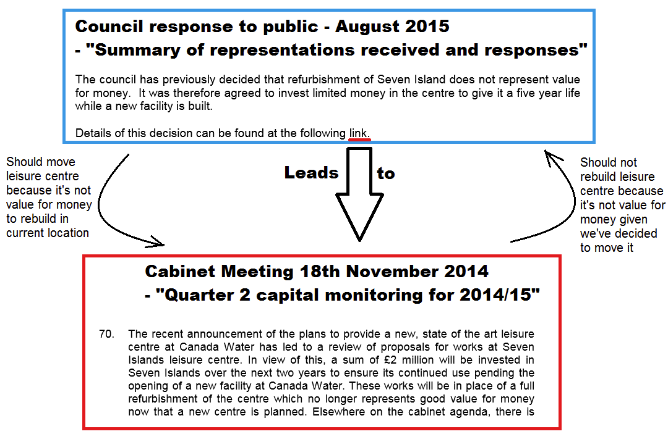
- August 2015’s Summary of representations and Reponses suggested they should move the leisure centre because refurbishing it does not provide value for money. Its evidence is from the Quarter 2 capital monitoring 2014/15” Cabinet meeting in November 2014 which said it would not be value for money to rebuild the leisure centre because they had decided to move it. This argument is entirely circular.
- We would like to see full public disclosure on any and all reports on the financial implications of either rebuilding or relocating Seven Islands Leisure Centre.
- The council have expressed concerns about having the leisure centre out of commission, yet there is empty ground on Seven Islands, and less used areas, meaning that the building could be rebuilt one section at a time (as many schools are, without any interruption to children’s learning).
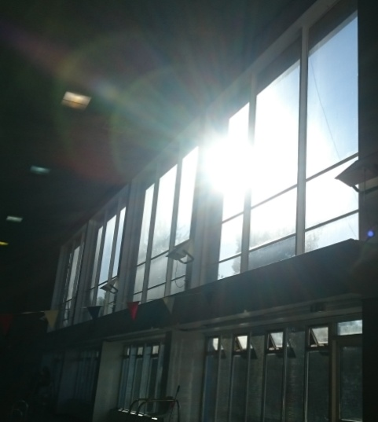
The current location of Seven Islands is great because:
- It is serviced by seven different bus routes (1, 47, 188, 199, 225, 381, P12) with bus stops less than 100m away. It is also only a 2-3 minute walk from Canada Water Station.
- The site is highly visible by a main road.
- The leisure centre benefits from a lot of natural light into the main pool area. This would not be possible if a new leisure centre has to be partially underground.
- The location has historical significance. It was originally the Rotherhithe Slippers Baths, built in 1880. It was rebuilt in 1963 as the Rotherhithe Baths, and renamed Seven Islands Leisure Centre in the 1980s.
We believe any consultation on the future of Seven Islands Leisure Centre should be done without a preferred new location, and that various other sites are considered including the option of keeping the building where it is.

